# SECTION VI

# MISCELLANEOUS INFORMATION

(Complete review done: 10/2024)

# HOW TO HOST A REGION MEETING

1. Chapters throughout the Rocky Mountain Region are asked to host Region Meetings.
2. A host chapter issues a written invitation to the RMR Board during a Region meeting. Region meetings are scheduled about one year in advance. Typical weather and travel conditions should be considered when setting the date.
3. Region meetings may be held virtually, in-person, or a combination (i.e., hybrid meeting) twice yearly at the discretion of the Region Director unless the date of the Board meeting coincides with an in-person event, in which case the meeting shall be held in-person. The annual meeting is usually held in conjunction with a region seminar/retreat In-Person Event. However, in the absence of these events, it may be scheduled independently. The spring meeting is generally held three or more months before the annual (usually late summer or fall) meeting.
4. Planning for the meetings must take place far enough in advance to advertise all the details in Border to Border.
5. Traditionally the region board meeting is held on a Saturday beginning at 9:00 am and ending no later than 4:00pm. The executive board meeting is usually held the evening before.
6. The host chapter arranges for a block of guest rooms at a hotel with reasonable rates. Breakfast should be available on site, if possible.
7. The host chapter arranges for meeting space. Meetings may be held at the hotel or at a nearby location.
8. The room for the region meeting/executive board meeting should accommodate 30 board members and guests. The executive board meeting is usually attended by up to 12 people.
9. The executive board will meet in the space incurring the least expense to the region. This may be at the same location as the region board meeting, in the Friday class location, or in a smaller meeting room, if more appropriate.
10. The meeting room(s) must meet the requirements for the Americans with Disabilities Act (ADA).
11. The region meeting set-up requires a head table at which the region director and the region secretary sit. A hollow square/rectangle is the best configuration. Extra tables may be needed in the room for display items and other materials. Extra chairs should be available for guests.
12. The host chapter arranges for lunch at the region board meeting. This may be done in various ways: through the hotel facilities, by ordering boxed lunches, or the host chapter may provide a pot luck luncheon. The region will pay reasonable costs for the lunch of board members. Check with the Region treasurer for the current allowance. Non-board member participants are charged for their lunch.
13. The host chapter supplies a list of nearby restaurants, sites and local shops that may be of interest to region members attending the meetings.
14. A class may be arranged by the host chapter and held on Friday in conjunction with the region meetings. The host chapter will set the price of the class and it will include teaching fees and kit or supply costs. The region will pay the room expense. Those who register for the class will make payment to the hosting chapter. All plans for the class and the day are the chapter’s responsibility.
15. The Host Chapter shall not incur any expense or profit for hosting a meeting. The region pays for the cost of the meeting space and boxed or catered lunches for region board members. The region will also pay the room expense for a Friday class.

# HYBRID/VIRTUAL (ZOOM) MEETINGS

For information regarding hybrid/virtual meetings, right click on the hyperlink below for the latest guidelines from EGA:

[EGA-Zoom-Hybrid-Meetings.pdf (egausa.org)](https://egausa.org/app/uploads/2022/06/EGA-Zoom-Hybrid-Meetings.pdf)

# LOGOS



**Rocky Mountain Region Logo**

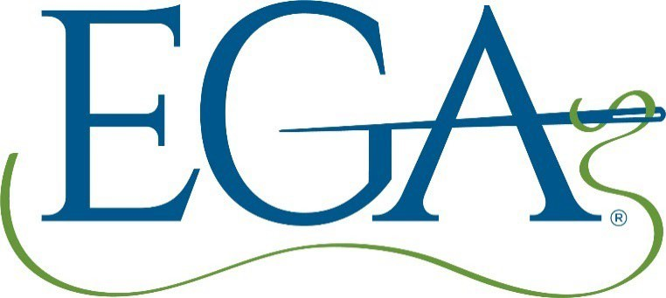

**Current EGA National Logo**



**Legacy Logo (No longer in circulation)**

For the most up to date information re: EGA branding, right click on the hyperlink [Marketing: Logos,](https://egausa.org/marketing/) [Brand Standards, and More | Embroiderers’ Guild of America (egausa.org)](https://egausa.org/marketing/), or contact Rand Duren at [mail to:rduren@egausa.org](mailto:rduren@egausa.org).

# EGA Diversity Statement

EGA is committed to providing a safe, inclusive, and supportive environment for stitchers of any experience level, age, race, ethnicity, nationality, ability, gender identity, sexual orientation, religion, or other background to develop their skills and express their creativity through the needle arts. EGA affirms the commitment to inclusion, diversity, equity, and accessibility (IDEA).

# Student Code of Conduct

EGA fosters values of honor, mutual respect, cultural sensitivity, integrity, and responsible conduct. Students are expected to behave consistent with these principles, whether attending in- person or virtual classes, displaying principles of common courtesy towards their teacher and fellow classmates.

1. Students will use their best efforts to listen during instruction and will not be disruptive.
2. Students will not unduly monopolize the teacher’s time and attention to the detriment of their fellow classmates.
3. Students will limit their contact with the teacher to classroom or online methods deemed acceptable by the teacher.
4. At the discretion of EGA, students who violate the code of conduct may be asked to leave the class and/or event.

# EGA Mission Statement

“Our Mission is to inspire passion for the needle arts through education and the celebration of its heritage.”

***Needle Arts* SUBMISSION GUIDELINES/FORM**

Right click on the hyperlink below to get the most current guidelines for submitting articles to NeedleArts magazine:

[Anc_4.1.1.7-Guidelines-for-Submitting-Articles-to-Needle-Arts-22-Jan-18.pdf (egausa.org)](https://egausa.org/app/uploads/2018/12/Anc_4.1.1.7-Guidelines-for-Submitting-Articles-to-Needle-Arts-22-Jan-18.pdf) You can also contact EGA National Office with any document retrieval questions - Rand Duren: [rduren@egausa.org](mailto:rduren@egausa.org)

**COPYRIGHT GUIDELINES**

For information regarding copyright laws, right click on the hyperlink below for the guidelines from the EGA:

[Anc_2.1.6.2.5-Copyright-Issues.pdf (egausa.org)](https://egausa.org/app/uploads/2018/12/Anc_2.1.6.2.5-Copyright-Issues.pdf)