SECTION 5

# RMR SEMINAR GUIDELINES

# FINANCES

(Revised 02/2025)

# RMR Seminar Finances

## General Financial Policies

1. In-Person Education Event financial policies shall adhere to the Rocky Mountain Region Bylaws and Policies and Procedures and Rocky Mountain Region Event Guidelines. The event treasurer must be familiar with these policies.
2. The in-person education events account will be separate from other region and chapter accounts.
3. The first item on the in-person event financial agenda is to create a workplan/budget to estimate event costs. "Workplan" is the name of the financial document until 30 days after the official first registration day, at which time it becomes the "budget".
4. Loan money in the amount of two thousand dollars ($2,000) may be advanced to the host chapter. One thousand dollars ($1,000.00) may be advanced two (2) years prior to the seminar upon acceptance of a preliminary workplan by the region director, treasurer, and assistant region director. The remaining one thousand dollars ($1,000.00) may be advanced to the seminar upon request and approval by the region director, treasurer, and assistant region director. Approval is contingent upon the seminar's compliance with RMR and national EGA policies and guidelines.
5. The Region shall not make or accept any monetary loans of any kind to or from any individual, entity, member, chapter, satellite, or region.
6. The Employer Identification Number (E.I.N) of the host unit (region or chapter) shall be used, and the account should be listed as “Host Unit Name” as Seminar 20xx.
7. Good accounting practices shall be maintained at all times.
8. The region treasurer shall prepare a final report named “Final In-Person Education Event Financial Report” to be sent to event coordinator within 90 days of closing of event.
9. All event financial records, including canceled checks and bank statements, shall be stored with region treasurer for 6 years.

## Seminar Workplan/Budget Preparation

1. The seminar treasurer shall work with the region event coordinator to prepare a workplan and final budget.
2. Items for consideration in the planning process:
3. Faculty costs – salary, travel, per diem
4. Estimated expenses for printing, postage, bank fees, credit card fees, office supplies, and web registration fee.
5. Registration Fee Calculation and Budget Work sheet
6. Additional expenses of invited guests (e.g., national president)
7. Event chair expenses (e.g., site visit for hotel selection)
8. Site contracts
9. The number of classes, lectures or other activities needed to serve the anticipated number of participants.
10. The minimum number of students per activity (class, lecture, etc.)
11. The maximum number of students per activity (class, lecture, etc.)
12. Registration fees using the Registration Fee Calculation Worksheet.
13. Non-participant fees
14. Event insurance
15. Review of previous event financial reports.
16. Decide how many classes are necessary to serve the anticipated number of participants. There should be a maximum of twenty-two students per class. Some classes will be full, and others may not meet the minimum number of students and must be cancelled. For most Rocky Mountain Region seminars, offering ten classes seems to be optimum.
17. Determine expenditures first. Begin by filling in the known items such as faculty costs (salaries, travel, room, and board). Add in estimates of expenses for printing, postage, bank fees, office supplies, brochures, etc. Refer to the Annotated Chart of Accounts for other items.
18. To figure the registration fee, see Registration Fee Calculation Worksheet.
19. “Break even” simply means the minimum number of registrants needed to pay all projected expenses. Any additional registration receipts provide surplus funds.
20. NOTE: The workplan may include provisions for the following:
21. Travel and lodging for dean of faculty to attend the faculty selection meeting for the previous year’s seminar.
22. Travel and lodging for dean of faculty to attend previous retreat to display class offerings.
23. Cost of a suite for the region director if one is not complimentary.

## Annotated Chart of Accounts

(This section can be found in the [Region Seminar Guidelines](https://egausa.org/app/uploads/2018/02/protected-rsg-section-iii-finance.pdf) on the EGA National website)

### Revenue

401 Registration: (see Registration Fee Calculation form to calculate fees, including non-refundable seminar fee.)

4011 Non-Refundable Seminar Fee: ranges from $70-$80. This is paid by all who enroll in classes. Non-participants (those not taking classes – volunteers, seminar chairs) may or may not pay this fee. Hospitality items may be a part of this fee, or those costs included in meal prices.

4012 Full Participation Fee– classes and all meals.

4013 First Half Participation Fee – half of classes (if classes are split between 1 and 2

days), meals as appropriate.

4014 Second Half Participation Fee - half of classes (if classes are split between 1 and 2

days), meals as appropriate.

4015 Volunteer Registration Fee – meals, hospitality items.

4016 Facilities Use Fee – generally ½ of room rate for those not staying on site.

4017 Refunds.

402 Banquet Guest Tickets:

4021 Opening Banquet – to calculate the cost of guest ticket add account balances 50121 through 50125 and divide by the total number of meals to be served.

4022 Closing Banquet – to calculate the cost of guest ticket add account balances

50131 through 50135 and divide by the total number of meals to be served.

4023 Refunds.

403 Merchandise Night: tables for merchants

4031 Whole Tables

4032 Half Tables

4033 Refunds

404 Teacher’s Kits (pass through to teachers, see 505 on Expenses).

405 Special Events: not included in registration fee.

406 Merchandise Sales: items that the seminar committee makes or purchases to sell.

407 Region Loan Money.

408 Interest Income.

409 Other Income

4091 Advertising income for student handbook.

4092 Contributions, donations.

4093 Payment for services – someone who stays in a comp room (Region Director’s roommate pays half the room rate for the nights she spends in the comp room).

4094 Miscellaneous.

### Expenses

501 Meals

5011 Meals included in registration, exclusive of banquets.

5012 Opening Banquet

50121 Food cost

50122 Speaker

50123 Decorations

50124 Favors

50125 Entertainment other than speaker

5013 Closing Banquet

50131 Food cost

50132 Speaker

50133 Decorations

50134 Favors

50135 Entertainment other than speaker

502 Site

5021 Room Rental: rates determined by contract.

50211 Region Director’s room if not complimentary

50212 Classrooms

50213 Regular Activity Rooms

50214 Special Events Rooms

50215 Exhibit Room

5022 Table and Chair Rental

5023 Beverage Service

5024 Miscellaneous Site Expense

503 Other Facility Costs

504 Faculty

5041 Salary: per contract

5042 Travel: reimburse teacher travel at rate specified in contract – generally lowest cost air fare or mileage reimbursement at stated rate. Includes other travel expenses as specified in contract.

5043 Rooms: as in contract

5044 Meals: per diem as specified in contract. Do not include meals included in 501.

5045 Teacher Gifts: bottled water, snacks

5046 Immigration Fees: Any non-United States citizen entering the country to teach at a seminar without a business visa must apply for the proper visa. EGA staff will complete and submit the application to the U.S. government. Check with EGA on the current fee. In 2022 fee was $160 per application.

5047 Faculty Selection Costs

505 Teacher Kits (see revenue 404).

506 Audio Visual Equipment Rental

507 Regular Activities

5071 Class Angels: identification pin

5072 Meet the Teachers

5073 Merchandise Night

508 Special Events not included in site costs.

509 Merchandise Sales – expenses for items that the committee makes or purchases for sale.

510 Brochure Publication

5101 Photography

5102 Printing

5103 Postage

5104 Other

511 Printing

5111 Participant’s Handbook

5112 Certificates

5113 Tickets

5114 Signs

5115 Other

512 Publicity

5121 Favors for distribution at seminar prior to this one

5122 Photography

5123 Other

513 Administration

5131 Chair

51311 Travel and lodging

51312 Telephone

51313 Postage

51314 Photocopying

51315 Miscellaneous

5132 Dean of Faculty

51321 Travel and lodging

51322 Telephone

51323 Postage

51324 Photocopying

51325 Miscellaneous

5133 Secretary

51331 Telephone

51332 Postage

51333 Photocopying

51334 Miscellaneous

5134 Treasurer

51341 Telephone

51342 Postage

51343 Photocopying

51344 Miscellaneous

5135 Registrar

51351 Telephone

51352 Postage

51353 Photocopying

51354 Miscellaneous

5136 Brochure Chair

51361 Telephone

51362 Postage

51363 Photocopying

51364 Miscellaneous

5137 Other Committee Chairs

51371 Telephone

51372 Postage

51373 Photocopying

51374 Miscellaneous

5138 Office Supplies

514 Hospitality Items

5141 Pins

5142 Tote bags

5143 Nametags (teachers, Region Director)

5144 Hostess Identification

5145 Door Prizes

515 Miscellaneous

5151 Bank Charges

5152 Security; locks, guards for office and classrooms

5153 Gratuities; to site staff for moving packages

5154 Cost of Goods Sold

5155 Other

516 Region Loan Repayment

**EXCESS** (LOSS) Calculation

**Host Unit Excess** - 50% when net revenue less net expense if is greater than 0.

**Host Unit Loss** – 50% if all policies adhered to; 100% if policies not followed.

**Region Excess** – 50% when net revenue less net expense is greater than 0.

**Region Loss** - 50% if policies adhered to; 0 if policies not followed.

# REGISTRATION FEE CALCULATION SHEET

|  |  |  |  |  |  |  |  |
| --- | --- | --- | --- | --- | --- | --- | --- |
|  | A | B | C | D | E | F | G |
| 1 | **REGISTRATION FEE CALCULATION** | | |  |  |  |  |
| 2 | Includes tuition for all days of class, Non-Refundable-Fee, All Banquets & Hospitality Items. | | | |  |  |  |
| 3 | **REGISTRATION EXPENSES** | | |  |  |  |  |
| 4 | 501 | Banquet |  |  |  |  |  |
| 5 | 502 | Hotel |  |  |  |  |  |
| 6 | 503 | Convention Center | |  |  |  |  |
| 7 | 504 | Faculty |  |  |  |  |  |
| 8 | 506 | Audio Visual and Equipment Rental | |  |  |  |  |
| 9 | 508 | Regular Activities | |  |  |  |  |
| 10 | 512 | Brochure Publication | |  |  |  |  |
| 11 | 513 | Printing |  |  |  |  |  |
| 12 | 514 | Publicity |  |  |  |  |  |
| 13 | 515 | Administration | |  |  |  |  |
| 14 | 516 | Hospitality Items | |  |  |  |  |
| 15 |  | List Tote Bags Separately Purchased | |  |  |  |  |
| 16 | 517 | Miscellaneous | |  |  |  |  |
| 17 |  |  |  |  |  |  |  |
| 18 |  | **TOTAL REGISTRATION EXPENSES** | |  |  |  |  |
| 19 |  |  |  |  |  |  |  |
| 20 | **REGISTRANTS** | |  |  |  |  |  |
| 21 |  | 4012 | 4 Day Class Fee (Full time students) |  |  | _classes w/_ in class |  |
| 22 |  | 4013 | First Two-Day Class Fee (.5 x no.registrants) |  |  | _classes w/_ in class |  |
| 23 |  | 4014 | Second Two Day Class Fee (.5 x no. of registrants) |  |  | _classes w/_ in class |  |
| 24 |  | 4015 | One Day Class Fee |  |  | _classes w/_ in class |  |
| 25 |  | TOTAL REGISTRANTS. | |  |  |  |  |
| 26 |  |  |  |  |  |  |  |
| 27 | **REGISTRATION FEE:** | | |  |  |  |  |
| 28 |  |  | 4 Day Class Fee |  |  |  |  |
| 29 |  |  | 2 Day Class Fee |  |  |  |  |
| 30 |  |  | 1 Day Class Fee |  |  |  |  |
| 31 |  |  |  |  |  |  |  |

Divide Total Registration Expense by number of participants who will share that expense to obtain registration fee.

# REGION SEMINAR FINANCIAL WORKPLAN/BUDGET

For the most up to date version of the Region Seminar Financial workplan/budget, click on the hyperlink: [Microsoft Word - RSG Section III - Finance.doc](https://egausa.org/app/uploads/2018/02/protected-rsg-section-iii-finance.pdf).

The most recent form is presented on the following pages.

.

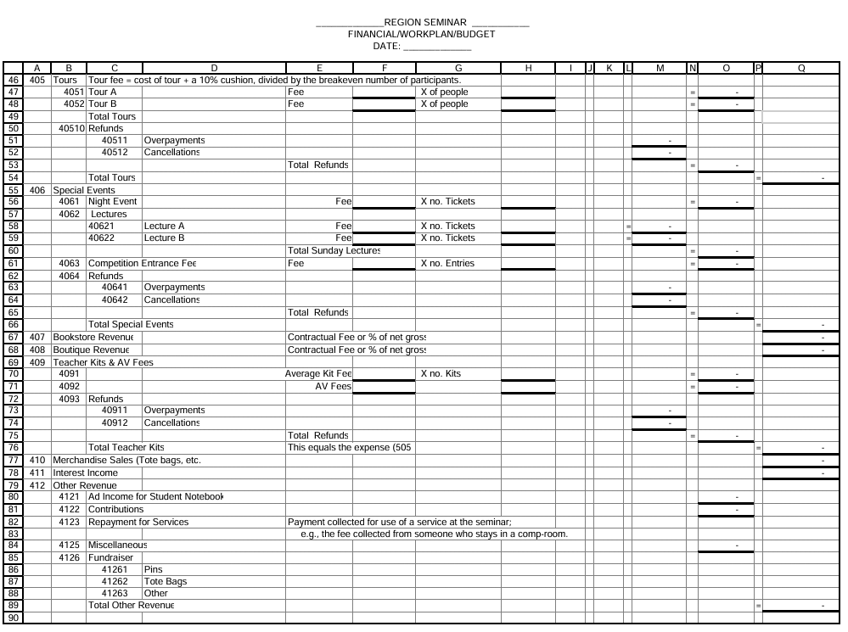

# Rocky Mountain Region Seminar 20xx

# Quarterly Financial Report

Quarter Ending _____________

|  |  |  |  |  |  |
| --- | --- | --- | --- | --- | --- |
| Account | Revenue | Budget | This Quarter | To Date | Balance |
| 401 | Registration |  |  |  |  |
| 402 | Banquet Guests |  |  |  |  |
| 403 | Merchandise Night |  |  |  |  |
| 404 | Teachers’ Kits |  |  |  |  |
| 405 | Special Events |  |  |  |  |
| 406 | Merchandise Sales |  |  |  |  |
| 407 | Region Loan Money |  |  |  |  |
| 408 | Interest Income |  |  |  |  |
| 409 | Other Income |  |  |  |  |
|  | Total Revenue |  |  |  |  |
|  |  |  |  |  |  |
|  | Expense |  |  |  |  |
| 501 | Meals |  |  |  |  |
| 502 | Site |  |  |  |  |
| 503 | Other Facility |  |  |  |  |
| 504 | Faculty |  |  |  |  |
| 505 | Teachers’ Kits |  |  |  |  |
| 506 | Audio Visual Equipment |  |  |  |  |
| 507 | Regular Activities |  |  |  |  |
| 508 | Special Events |  |  |  |  |
| 509 | Merchandise Sales |  |  |  |  |
| 510 | Brochure Publication |  |  |  |  |
| 511 | Printing |  |  |  |  |
| 512 | Publicity |  |  |  |  |
| 513 | Administration |  |  |  |  |
| 514 | Hospitality Items |  |  |  |  |
| 515 | Miscellaneous |  |  |  |  |
| 516 | Region Loan Repayment |  |  |  |  |
|  | Total Expense |  |  |  |  |
|  |  |  |  |  |  |
|  | Excess (Loss) |  |  |  |  |
|  | **(Please attach copies of all Bank Statements for the period covered by this report)** |  |  |  |  |
|  | Beginning Checkbook Balance |  |  |  |  |
|  | Deposits |  |  |  |  |
|  | Withdrawals (checks) |  |  |  |  |
|  | Ending Checkbook Balance |  |  |  |  |

# Rocky Mountain Region EGA Seminar 20xx

# Monthly Financial Report

# Month Ending _____________

|  |  |  |  |  |  |
| --- | --- | --- | --- | --- | --- |
| Account | Revenue | Budget | This Month | To Date | Balance |
| 401 | Registration |  |  |  |  |
| 402 | Banquet Guests |  |  |  |  |
| 403 | Merchandise Night |  |  |  |  |
| 404 | Teachers’ Kits |  |  |  |  |
| 405 | Special Events |  |  |  |  |
| 406 | Merchandise Sales |  |  |  |  |
| 407 | Region Loan Money |  |  |  |  |
| 408 | Interest Income |  |  |  |  |
| 409 | Other Income |  |  |  |  |
|  | Total Revenue |  |  |  |  |
|  |  |  |  |  |  |
|  | Expense |  |  |  |  |
| 501 | Meals |  |  |  |  |
| 502 | Site |  |  |  |  |
| 503 | Other Facility |  |  |  |  |
| 504 | Faculty |  |  |  |  |
| 505 | Teachers’ Kits |  |  |  |  |
| 506 | Audio Visual Equipment |  |  |  |  |
| 507 | Regular Activities |  |  |  |  |
| 508 | Special Events |  |  |  |  |
| 509 | Merchandise Sales |  |  |  |  |
| 510 | Brochure Publication |  |  |  |  |
| 511 | Printing |  |  |  |  |
| 512 | Publicity |  |  |  |  |
| 513 | Administration |  |  |  |  |
| 514 | Hospitality Items |  |  |  |  |
| 515 | Miscellaneous |  |  |  |  |
| 516 | Region Loan Repayment |  |  |  |  |
|  | Total Expense |  |  |  |  |
|  |  |  |  |  |  |
|  | Excess (Loss) |  |  |  |  |
|  | **(Please attach copies of all Bank Statements for the period covered by this report)** |  |  |  |  |
|  | Beginning Checkbook Balance |  |  |  |  |
|  | Deposits |  |  |  |  |
|  | Withdrawals (checks) |  |  |  |  |
|  | Ending Checkbook Balance |  |  |  |  |

# SEMINAR BUDGET FINAL REPORT

# Rocky Mountain Region EGA Seminar 20xx

# Request for Reimbursement

Date: Amount

Requested by: Committee:

Please pay to:

Name:

Mailing Address:

Telephone: E-mail:

Brief explanation with **original** receipts attached: (list postage, printing, etc.)

Is this a donation-in-kind? If so, how much:

Approved by:

Paid Check # Date:

Accounts:

# [IC Payment Reporting Form](https://egausa.org/app/uploads/2024/10/protected-ic_payment_reporting_form13_2.pdf)

For the most up to date copy, click on the hyperlink provided, or send an email request to <mailto:rduren@egausa.org>