SECTION III

BYLAWS, POLICIES, AND PROCEDURES
(Complete review done: 4/2016)

EGA NATIONAL BYLAWS

To have the most up to date version of the EGA National Bylaws, right click on the hyperlink below:
Microsoft Word - EGA-National-Bylaws-2024 FINAL (egausa.org)
or contact Rand Duren –mailto:rduren@egausa.org

The Embroiderers’ Guild of America, Inc.

Rocky Mountain Region Bylaws: 2015

ARTICLE I NAME; USE OF EGA’S TRADEMARKS
The name of this organization shall be the Rocky Mountain Region (RMR) of The Embroiderers’ Guild of America, Inc. (EGA). While this region is recognized as a region of EGA, the region and its member chapters may use EGA’s registered trademarks: the name “The Embroiderers’ Guild of America, Inc.,” the stylized needle and thimble logo and design, and the letters “EGA,” under standards approved by EGA. All use of such registered trademarks shall be discontinued upon the suspension, withdrawal of recognition, resignation, or dissolution of this region.

ARTICLE II OBJECT
The purpose of this region shall be to foster the highest standards of excellence in the practice of the art of embroidery through an active program of education and study, and to preserve the heritage of the art of embroidery, to serve as a link between chapters and the national organization, and to aid in effective cooperation and communication among its member chapters.

ARTICLE III MEMBERSHIP
Section 1. The Rocky Mountain Region shall be composed of chapters within the geographic boundaries as defined by the EGA board of directors. Membership in a chapter confers membership in its respective region. Any person, regardless of race, gender, religion, national or ethnic origin may become a member of the individual chapters upon application and payment of dues.
Section 2. Annual region dues shall be payable to the region treasurer by the chapter treasurers. Region dues are to be concurrent with the members’ national and chapter dues.
Section 3. Dues shall be set by the RMR board of directors. Those chapters whose dues are not current may, at the discretion of the executive board, have voting or other privileges suspended until all dues are paid. New member dues shall be paid to EGA and Rocky Mountain Region at the time the individual joins.
Section 4. Region dues for transfer and plural members shall be paid by the chapter to the region treasurer, provided the member’s national dues are current. Plural members of the region whose primary dues are collected outside the region shall pay region dues to the member chapter with which they plural. A plural member pays region dues only once annually to each region in which the member holds a plural membership.

ARTICLE IV OFFICERS
Section 1. The elected officers of this region shall be a region director, an assistant region director, a secretary, a treasurer, and a nominating committee chair. Officers shall be members of a chapter within the region.
Section 2. Officers shall serve for a term of 3 years (beginning in 2016), or until their successors are elected, and the term of office shall begin January first.
Section 3. No elected officer shall be eligible to serve more than 1 term in the same office, and no member shall hold more than one region elected office at a time.
Section 4. No region elected officer may serve concurrently as a region representative.
Section 5. Whenever possible, successive region directors shall not come from the same chapter.(9/2022)
Section 6. No region director may serve concurrently as a nationally elected EGA officer or director.
Section 7. The RMR director shall be a voting member of the EGA board of directors. If the director is unable to attend an EGA board of directors’ session, the assistant director, or a representative appointed by the RMR executive board, shall become the voting RMR representative member at the meeting.
Section 8. If a vacancy occurs in the office of region director, the assistant region director shall automatically become region director. Vacancies in the offices of assistant region director, secretary and treasurer shall be filled through election by the remaining executive board from a slate submitted by the nominating committee.
Section 9. Vacancy in the office of the nominating committee chair shall be filled by one of the remaining members of the nominating committee if the committee has been selected. The vacant position on the committee will then be filled with an appointee selected by the executive board and ratified by the region board, as soon as is possible. If no committee is in place at the time of the vacancy, a new nominating committee chair shall be selected by the executive board and ratified by the region board, as soon as is possible.
Section 10. The duties of the officers shall be carried out as prescribed by the EGA bylaws, policies, and procedures; the RMR bylaws, policies, and procedures; and/or the region parliamentary authority.
Section 11. Nominations and Elections:
  - A nominating committee of at least 2 members shall be elected at the last Board meeting of the year preceding the election. No chapter shall have more than one member on the committee. No member may serve more than 2 consecutive terms. Should a vacancy occur, the executive board shall select a successor. It shall be the duty of the nominating committee to nominate at least one candidate for each of the offices to be filled and to submit the names to the region board 6 weeks prior to the election, having obtained consent for nomination from each.
  - The names and resumes of the candidates shall be reported in the region newsletter and/or shall be sent to each chapter president and RMR board member no less than 5 weeks prior to the election.
  - The election of new officers shall be held no less than 4 weeks prior to the end of the term(s) of the current officers. Additional nominations from the floor may be made up to 1 week prior to the election, providing consent to serve has been obtained from the nominees prior to the election. If there is more than one candidate for an office, the vote shall be taken by ballot.
  - The nominating committee shall submit for election, the name of a candidate for the national nominating committee concurrent with each region election cycle.

ARTICLE V MEETINGS AND NOTICE
Section 1. The region shall hold at least 2 meetings per year .
Section 2. The annual meeting shall be the second meeting of the year.
Section 3. A written notice of regular and annual meetings shall be sent to member chapters at least thirty (30) days prior to the meeting.
Section 4. Special meetings may be called by the region director; by the executive board; by 5 members of the board of directors; or by any three member chapters. At least a fourteen-day notice stating the business of the special meeting is required and no business other than that stated in the notice may be transacted.
Section 5. The quorum for all region meetings shall be one-third of all voting members of the board.
Section 6. Voting without an in-person meeting: Any action required or permitted to be taken by the board, or any committee thereof may be taken without an in-person meeting provided that all members of the board or committee are notified in writing or by electronic means. Two-thirds of the responding members of the board or committee must consent in writing or by electronic means to the adoption of the resolution authorizing the action. Abstention is not a vote and is not counted as a vote. If an action without an in-person meeting is deemed necessary by the board, the action must be ratified at the next regular board meeting to become an official act of the board.
Section 7. If substituting an electronic meeting for an official board of directors meeting, all board members must be notified of the meeting.

ARTICLE VI BOARD OF DIRECTORS
Section 1. The board of directors shall be composed of the executive board, the chapter region representatives, and the region sponsored EGA national special events chair(s). Each member has one vote
Section 2. The region director shall appoint a parliamentarian, with the approval of the executive board. The appointment shall be announced at the first region meeting after the election or as appropriate. The parliamentarian shall serve without a vote.
Section 3. Board members serving in more than one capacity shall have one vote.
Section 4. The board shall have supervision of the affairs of the region; fix the day, hour, and place of region meetings; and conduct such other business as is necessary to the operation of the region.

ARTICLE VII EXECUTIVE BOARD
Section 1 The executive board shall be composed of the elected officers of the region and the standing committee chairs.
Section 2. The executive board shall supervise the affairs of the region between meetings of the board of directors and perform other duties specified in the RMR bylaws, RMR policies and procedures and/or by the region board of directors. Any action taken by the executive board shall be reported to the region board.
Section 3. Each member of the executive board shall have one vote.
Section 4. The executive board shall meet at the discretion of the region director or upon request of two of its members.
Section 5. The quorum for the executive board shall be a majority of its members.

ARTICLE VIII COMMITTEES
Section 1. The standing committees of this region shall be bylaws /policies, Director’s Club, education, fund raising, historian/Dropbox administrator (10/2024), marketing/membership, newsletter editor, outreach, Prospectors, web liaison, and online communications.(05/2023)
Section 2. The region director shall appoint all standing committee chairs, subject to approval by the executive board.
Section 3. The term for the appointed standing committee chairs and members shall be concurrent with the term of the region director who appointed them.
Section 4. Special committees or additional standing committees shall be appointed by the region director to carry out particular work of the region; the appointments shall be subject to approval by the executive board.
Section 5. The region director shall be an ex officio member of all committees except the nominating committee.

ARTICLE IX FISCAL POLICIES
Section 1. The fiscal year shall be from January 1 through December 31.
Section 2. The books and accounts of the region shall be kept in accordance with sound accounting practices. Region financial records shall be audited each year, either professionally or by an audit committee appointed by the region director, prior to the submission of the annual report. The treasurer shall furnish EGA with a report of the finances of the region by February 15 of each year.
Section 3. No one may profit from membership in EGA; however, an EGA region may contract with individual members in their professional capacities. EGA prohibits the use of membership lists other than for EGA purposes.
Section 4. Annual Budget:
- The region shall prepare and present a budget to the membership for approval no later than November 1 of the year prior to the effective date of the budget.
- The region shall prepare and present a budget to the membership for approval no later than November 1 of the year prior to the effective date of the budget.
- The board of directors and/or the executive board shall not spend any non-budgeted funds more than $500 during the fiscal year. The region may approve an expenditure more than this amount provided:
    - the membership is notified in writing at least thirty days prior to the meeting at which the vote is taken
    - The written notice shall include the amount and purpose of the expenditure, and
    - the approval is by a two-thirds vote.
Section 5. Donations: Donations of monies by the region may be made to any organization which is in compliance with Section 501(c)(3) of the United States Internal Revenue Code and which the region, by a two-thirds vote, has designated as the recipient. Notice of such a proposed donation shall be submitted to the members in writing at least thirty days prior to the meeting at which such vote is taken.
Section 6. Dissolution: in the event of dissolution of the region, all its assets and funds remaining after payment or provision for payment of all debts and liabilities of the region shall be distributed to one or more organizations which have been in existence for a period of two years, which are in compliance with Section 501(c)(3) of the United States Internal Revenue Code, and which the region has designated as a recipient by a two-thirds vote. Notification to the membership shall be provided in writing at least thirty days prior to the meeting at which such a vote is to be taken.
Section 7. Indemnification of Directors or Officers. The Indemnification of Directors and officers in Article X, EGA National Bylaws, specifies that EGA may indemnify the region director, director-elect, assistant director, secretary, treasurer, and any other elected officers of this region as described in Article IV, Section 2 D of the EGA National Bylaws.

ARTICLE X PARLIAMENTARY AUTHORITY
The rules contained in the current edition of Robert’s Rules of Order Newly Revised shall govern the region in all cases to which they are applicable and in which they are not inconsistent with the Bylaws of The Embroiders’ Guild of America, Inc., any special rules of order the region may adopt, or any statutes applicable to this organization.

ARTICLE XI AMENDMENT TO BYLAWS
Section 1 Any bylaw amendment(s) effected by EGA that necessitates amendment(s) to the region bylaws shall be incorporated automatically in the region bylaws and the membership shall be informed of such changes at the next regular meeting.
Section 2 These bylaws may also be amended by a two-thirds vote at any regular meeting of the region or between scheduled meetings in compliance with our on-line voting procedure, provided the proposed amendment has been submitted in writing to the membership at least thirty (30) days in advance and that the proposed amendment has received the approval of The Embroiderers’ Guild of America, Inc., prior to the meeting or the vote.

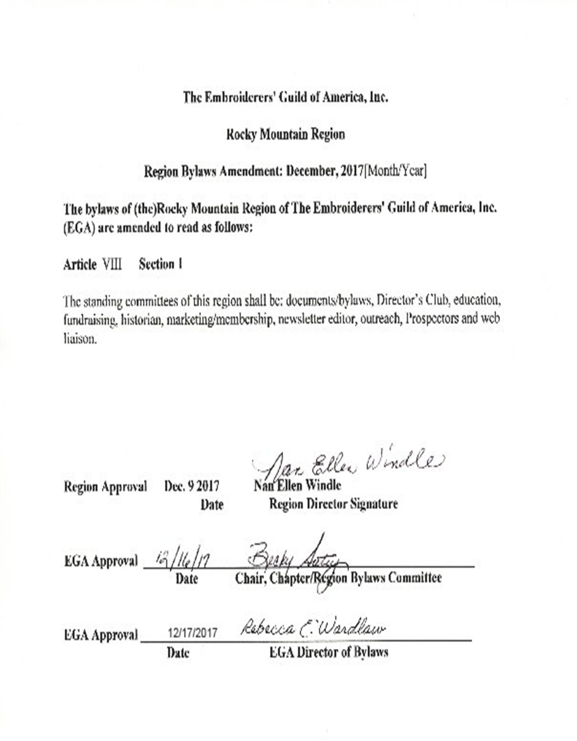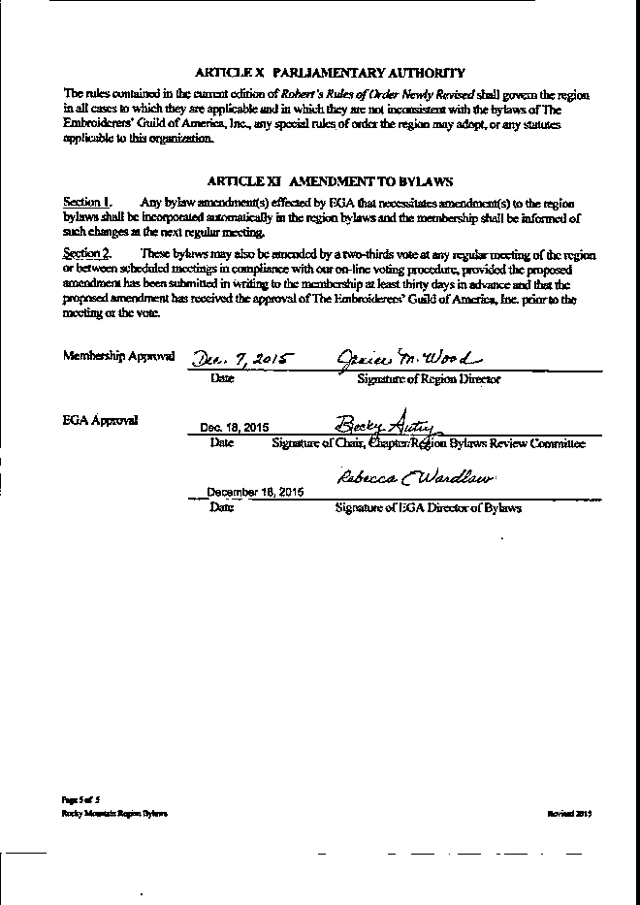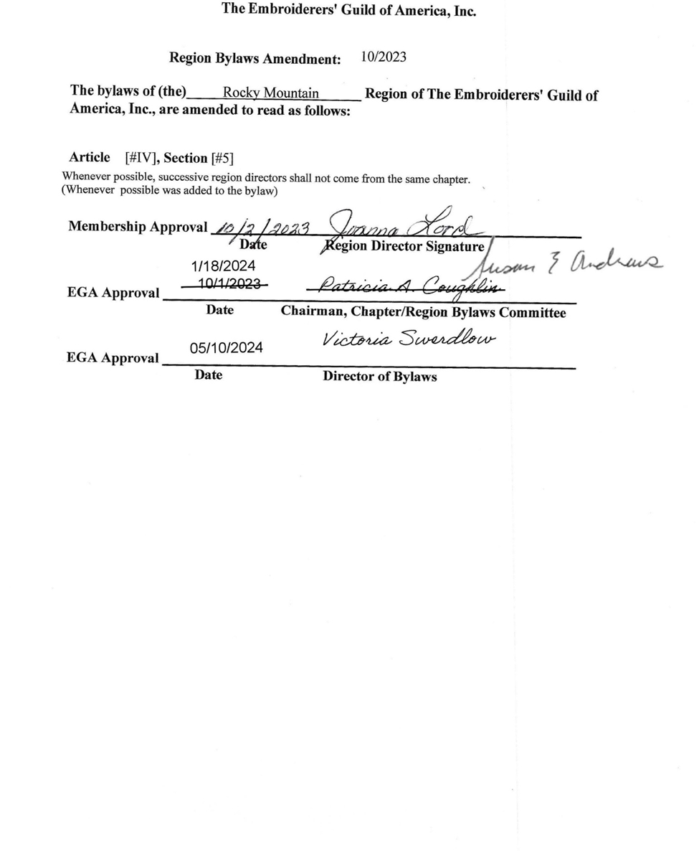
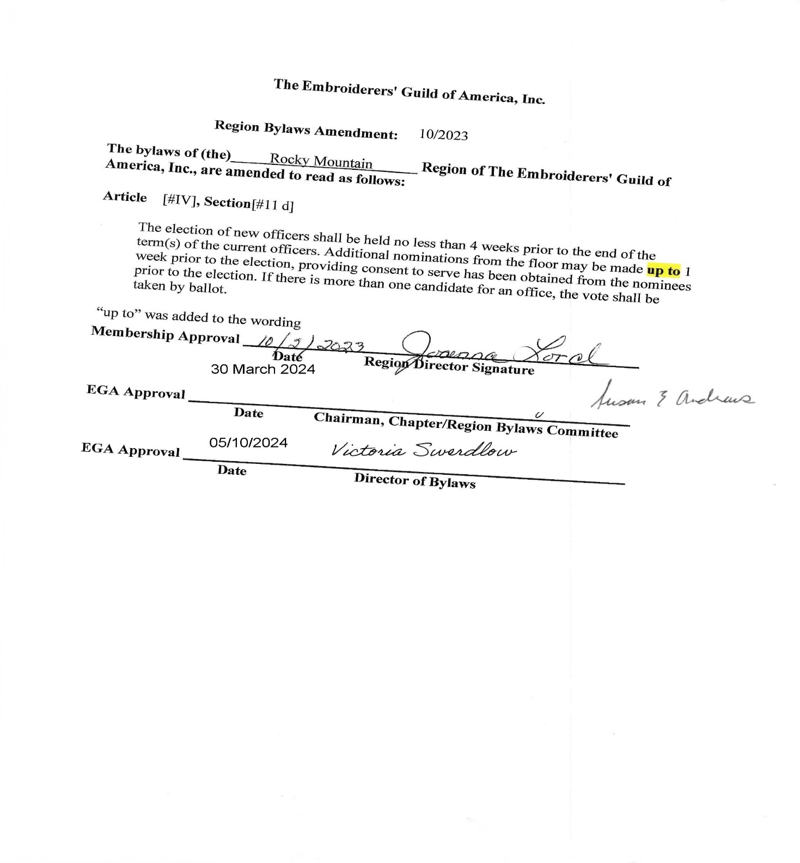
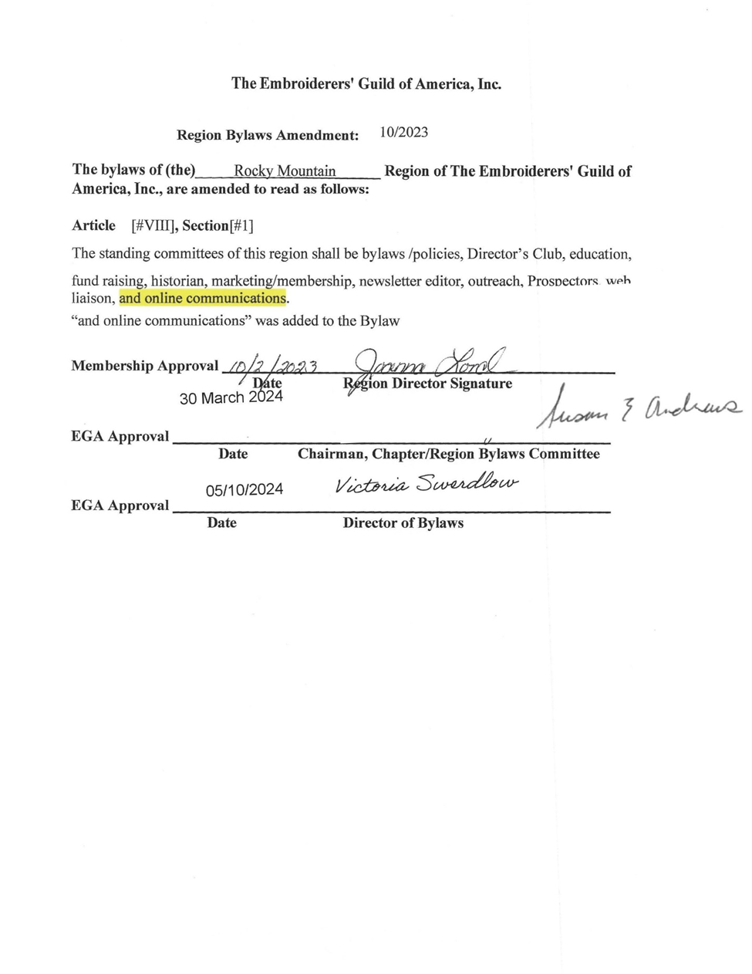

The Embroiderers' Guild of America, Inc.
Region Bylaws Amendment: October 2024]
The bylaws of (the) Rocky Mountain Region of The Embroiderers' Guild of America, Inc., are amended to read as follows:
Article [VIII], Section[1]

Section 1. The standing committees of this region shall be bylaws/policies, Director’s Club, education, fundraising, historian historian/Dropbox administrator, marketing/membership, newsletter editor, outreach, Prospectors, web liaison, and online communications.
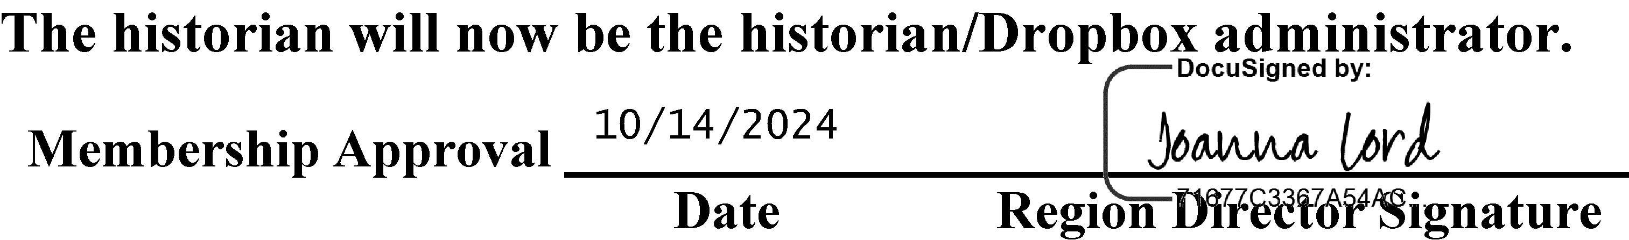
The historian will now be the historian/Dropbox administrator.
Membership Approval
Date
Region Director Signature
EGA Approval

Date
Chairman, Chapter/Region Bylaws Committee
EGA Approval

Date
Director of Bylaws

The Embroiderers' Guild of America, Inc. Region Bylaws Amendment: October 2024

The bylaws of (the) Rocky Mountain Region of The Embroiderers' Guild ofAmerica, Inc., are amended to read as follows:

Article [IV], Section [11.a]
a. A nominating committee of at least 2 members shall be elected at the first meeting in an election year last Board meeting of the year preceding the election. No chapter shall have more than one member on the committee. No member may serve more than 2 consecutive terms. Should a vacancy occur, the executive board shall select a successor.
The portion of the amendment in yellow that is struck out will be replaced with the text in green.

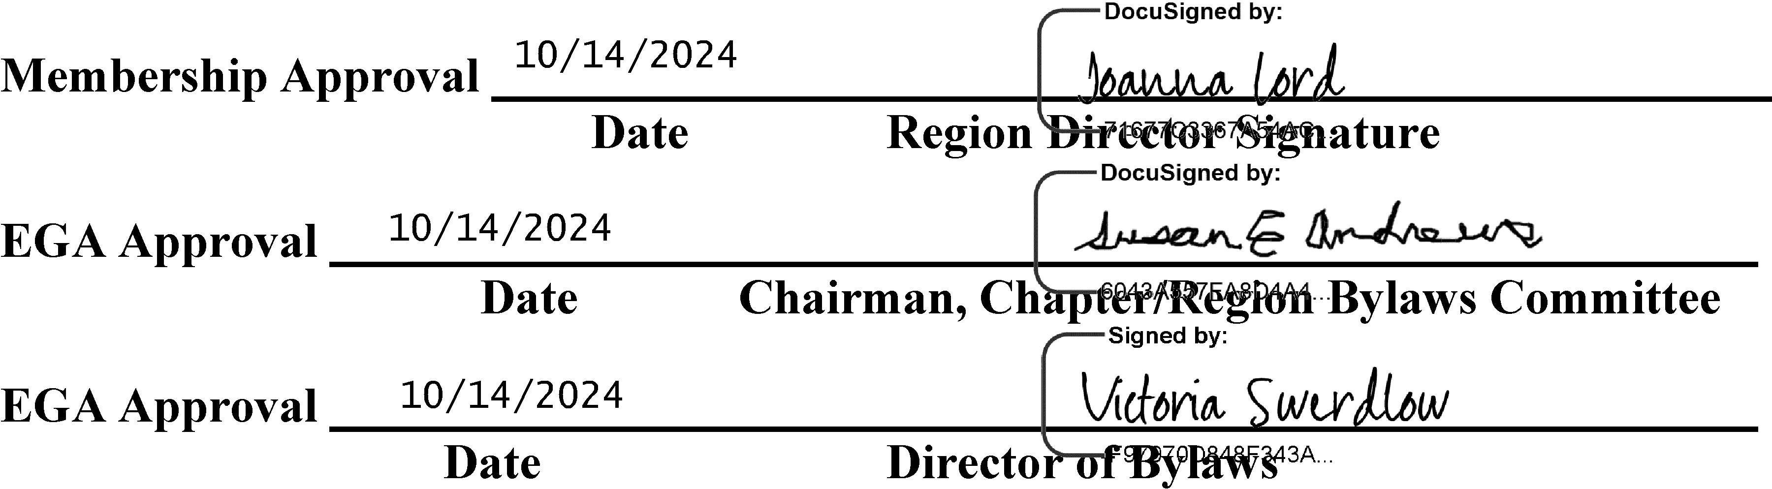

EGA NATIONAL POLICIES AND PROCEDURES

For the most up to date version of the EGA National Policies and Procedures, right click on the hyperlink below:
protected-EGA-POLICIES-Manual-2024.docx (live.com)
or contact Rand Duren mailto:rduren@egausa.org

POLICIES AND PROCEDURES

Governance
- To participate fully and receive the benefits of the region, member chapters have the following responsibilities:
- Attend region meetings and be an active participant in region activities.
- Report region activities to the chapter and convey the chapter’s wishes and needs to the region director and the board.
- Submit chapter news to Border to Border.
- Keep a current file of the region roster and minutes.
- Be familiar with the Region Officers’ Notebook and RMR Policies and Procedures, located on the region’s website.
- Provide region director and national office with the current list of chapter officers.
- The Chapter shall provide the region director with:
- A copy of the minutes from ALL chapter meetings and executive board meetings
- Current chapter roster and updates
- Copy of chapter newsletters (if mailed) or notification of posting online.
- Chapters are encouraged to reimburse their region representative for expenses when attending region meetings.
- The region documents/bylaws chair maintains the master copy of the Region Officers’ Notebook (RON) on an external electronic device and makes any changes or additions following the protocol below:
- Changes will come from:
- Board meetings and/or e-mail “meetings”
- Region director
- Once the documents/bylaws chair has made the changes to the RON, a copy is sent to the region director to verify. Once verified by the region director, the revised section (of the RON) wherein the changes took place, is put into the master copy on external electronic device.
- The documents/bylaws chair will also send approved changes to web liaison:
- Sends entire Section where change(s) took place, so webmaster only must replace the Section.
- Sends the information in the format required by the webmaster.
- Webmaster will make changes on the website.
- Web liaison will inform documents/bylaws chair that changes are posted on the website.
- Documents/bylaws chair will notify region secretary that changes are posted on the website. A list of the changes and where the changes have been made will be included in the notification. Region secretary will pass this notification and list on to region board member

Region Meetings
- Region board meetings may be held virtually, in-person, or a combination (i.e., hybrid meeting) twice yearly at the discretion of the Region Director unless the date of the Board meeting coincides with an in-person event (e.g., Region Education event), in which case the meeting shall be held in-person.(05/2023)
- The region secretary sends out the Call to Meeting, attendance/lunch reservation form, and proxy thirty (30) days prior to the region meeting.
- All region board members are required to return their attendance/lunch reservation form to the secretary within the time limit requested.
- A proxy form will also be included with the Call to Meeting for the purpose of allowing a chapter to vote in absentia.
- Proxies may be assigned to a member of the chapter for purposes of representing chapter members and voting on business measures at region meetings. Proxies should be dated and signed if returned by mail or filled-in with identification if returned by email.
- The region secretary sends out the board packet which consists of chapter and officer reports, agenda, and any additional meeting information at least ten (10) days prior to the meeting.
- Minutes of previous meetings need not be read aloud because each board member shall have been sent a copy.
- Unscheduled Meeting Protocol: When it is necessary for a board/committee to conduct business between scheduled meetings, the following are the recommendations set by the region board of directors:
- Region director/committee chair sets the time and/or dates of the meeting with a seven (7) day minimum notice, except in cases of emergency.
- Director/chair sets agenda for meeting (with input from board/committee members as needed) and sends it out at least three days before scheduled meeting.
- In the case of an emergency meeting, only the emergency topic will be on the agenda.
- The region secretary shall keep records for a board meeting. Committee chair shall select a record keeper for the committee meeting. The secretary/record keeper will be the conduit for the communications during the meeting.
- The secretary/record keeper will record the names of those participating in the meeting.
- If a motion needs to be made during an unscheduled meeting the protocol below is followed.
- Presenting a motion and voting:
- All motions must be in writing and sent to secretary/record keeper. The rationale for the motion shall be included.
- The secretary/record keeper will second the motion and send the motion to the appropriate recipients and will set the time line for discussion and voting.
- Recipients will be asked to acknowledge receipt of the motion within the designated time frame.
- The secretary/record keeper will record the names of those acknowledging receipt of the motion.
- All discussion must include all participants.
- Should an amendment be made to a motion, the same procedure as making the motion is followed.
- Once the vote is called, the secretary/record keeper will record the names of those who vote, along with their vote – yes, no, or abstain.
- All votes must be in writing.
- If a ballot is necessary, it shall be designed with a space for the voter’s signature or identification (if voting by email) and full instructions for marking and returning.
- Two thirds of the responding members of the board/committee must vote in favor of the motion for adoption.
- The secretary/record keeper shall immediately send the results of the vote to all board/committee members.
- If a motion is passed in an unscheduled meeting, it must be ratified at the next regular region board meeting

Elections (05/2023)
- Nominating Committee presents the slate to the region director by March 15.
- Slate (along with nominees’ biographies and pictures) is sent to the region board for approval on April 1.
- Approved slate is published in Border to Border (along with nominees’ biographies and pictures) by April 15. Notification of this publication must be sent to region representatives.
- Nominations from the floor will be accepted until May 15.
- Region secretary sends ballots to the chapters on May 22. Voting closes on June 30. Region secretary announces the results of the election by July 15.

Dues
- Annual dues of five dollars ($5) per chapter member shall be paid to the region as set forth in the bylaws.
- Payment of national dues is a requirement for participation in any region activity.
- Dues shall be deposited into the region’s banking account by national EGA for all chapter primary members.
- Life Member and Out of Region Plural Member region dues shall be paid to the region treasurer by the member’s RMR chapter.

Finances
- All region monies shall be kept in federally insured institutions. Money shall be deposited in interest-bearing accounts if minimum balance can be maintained.
- All accounts will have three signature authorities: the region director, assistant region director, and the region treasurer.
- Officers and committee chairs shall submit Request for Reimbursement Form to the region treasurer, along with receipts, for reimbursement or recording (when no reimbursement is desired). Requests must be submitted within the year that the expenses were incurred.
- The region director shall approve all requests for reimbursement submitted for the region treasurer’s expenses.
- NON-SUFFICENT FUNDS POLICY: Cash, money order, or cashier’s checks shall be required from members who have outstanding, non-collectible, returned checks payable to an EGA chapter, region, or national. All documented returned check expenses associated with NSF checks shall be charged back to the issuer including returned check fee assessed by the bank, all other documented expenses associated with the return check, plus a $25.00 handling fee.
- The region’s financial books shall be audited at the close of each calendar year. The audit committee will consist of two individuals, or a professional auditor appointed by the region director. Region director will notify the executive board of appointees (per bylaws).
- The outgoing region treasurer will send the Annual Financial Report to EGA by the 15th of February.
- After the audit, all accounts will be transferred to the new signatories by March 1.
- The region will reimburse the region director for the following expenses, up to the amount budgeted:
    - Travel to national board sessions at the lowest available airfare and a per diem rate for meals. The per diem rate will be determined from the IRS, Per Diem Rates.
    - Travel within region for chapter visits, budget permitting.
    - Administrative expenses for postage, photocopying, telephone, etc.
- Prior to taking office in January, the incoming region director shall be reimbursed for travel, lodging, and per diem to the same extent as current region director, to attend a national board session.
- The Rocky Mountain Region financial report shall be published in Border to Border at the end of the second and fourth quarters of the year.

Newsletter
- Border to Border is the official publication of this region.
- The newsletter shall be distributed to:
    - All region officers and committee chairs.
    - All region chapter presidents, region representatives, and newsletter editors.
    - National board members and all other region newsletter editors
- Border to Border will be offered at no charge to all region members and members-at-large in an electronic format.
- Advertising deemed appropriate to the interests of the member chapters in the region will be accepted, at a rate to be determined by the region board.

Clare Award
- The Clare Award is given to a member who has given of themselves continually in the Rocky Mountain Region above and beyond the normal dedication of our members. Their noteworthy performance can be in any of several aspects: administration, teaching, works that show excellence in the art of embroidery, or any other way which brings positive attention to our region and EGA through skill and attitude.
- This award may be given:
- One or more in any one year.
- None in the year.
- No posthumous nominations will be accepted.
- Selection:
- When the name of a member of the RMR is to be presented for consideration for the Clare Award, the presenter must provide, in writing, the name to be considered, chapter affiliation, a synopsis of all EGA offices held, and a paragraph listing the reasons, the presenter feels the member should be a recipient.
- Nominations are accepted by the region director up to four (4) weeks prior to the first region board meeting of the year so the nominations can be discussed and voted on by the executive board members. Nomination received after the four (4)-week deadline, will be considered for the following year. If three-fourths (3/4) of the executive board members concur, ballots will be sent to each member of the region board at least eight (8) weeks prior to the meeting at which the award will be presented. The approval ballot shall be returned to the region director by the date indicated. If a nominee does not receive a three- fourths (3/4) vote of the executive board members, the person making the original recommendation will be notified in writing.
- Each name presented will be considered on its own merit. The original nomination information will be sent to all voting region board members. Each name will appear on a separate ballot to ensure individual consideration.
- A three-fourths (3/4) majority of the region board is required for the award.
- After the voting, the secretary will tabulate the ballots and report the name(s) of those selected for the award to the region director.
- Ideally, the award should be presented at a region seminar banquet along with the pin, certificate, and the chart of St. Clare.
- Each recipient's name and year of award shall be added to the St. Clare banner.

Region Seminar Policies
- A region seminar may take place in any given year with the approval of the Region Board.
- The seminar committee is a special committee of the Rocky Mountain Region. The seminar chair does not sit on the region board.
- The Assistant Region Director acts as the Seminar Coordinator.
- The region will use the current EGA-contracted event services company to help secure the venue for region seminars. No contact of any kind with any venue will occur prior to enlisting this company to begin the search. Contact with the company will initiate through the RMR Seminar/Retreat Coordinator.
- A region seminar may be held in conjunction with the annual region meeting. The Region shall follow national policy regarding region seminars and, as applicable, the latest information in Region Seminar Guidelines. (Right click on hyperlink) - Microsoft Word - Table of Contents - Introduction.doc (egausa.org)
- The region shall schedule its seminar upon acceptance of an invitation by a chapter, preferably two years in advance. Chapters may co-host a seminar. Hosting chapters shall, upon acceptance, provide their proposal for delineation of duties.
- For a region-hosted seminar, the chair shall be selected by the region director and the assistant region director and ratified by the region executive board of directors. The seminar chair shall choose committee chairs from as many chapters as possible.
- For a region seminar hosted by chapters, the chair is selected by the host chapter(s) and ratified by the region executive board in a timely manner. A synopsis of background information relating to the position for the proposed chair shall be submitted to the region director who will then distribute it to the region executive board prior to the ratification vote.
- The seminar chair selects all committee chairs. The chair will submit the name and synopsis of background information relating to the position of the dean of faculty, treasurer and registrar to the region director within 30 days of the chair’s ratification. The region director will send the information to the region executive board members, and they will ratify these selections in a timely manner.
- Seminar checking and savings accounts require that one of the elected region officers (one who lives as close to the host chapter as possible) be a signatory on all the accounts.
- Job descriptions for the seminar chair, seminar dean of faculty, seminar treasurer and seminar registrar are policies which must be observed – descriptions are found in the Rocky Mountain Region Seminar Guidelines.
- The treasurer of a seminar shall not be treasurer of any other unit of The Embroiderers’ Guild of America, Inc. from the time of appointment through the sending of the complete Final Seminar Financial Report at the end of the seminar.
- Printing out teacher proposals is prohibitively expensive. To ensure seminar expenses are kept to a minimum, all teacher proposals are to be shared via electronic means, whether faculty selection committee is meeting virtually or in-person.
- Any surplus from the seminar will be shared between the region and host chapters with 40% going to the region and 60% going to the host chapter(s). If a deficit can be foreseen after all cost-cutting measures have been taken, including canceling low enrollment classes, the seminar will be canceled. Any deficit will be divided with 50% of the shortage borne by the region and 50% by the host chapter(s). (See item J above.)
- If a seminar must be canceled, the termination shall be accomplished by the teacher cancellation date indicated in the teachers' contracts or by the facilities contract cancellation date, whichever is earliest.
- Loan money in the amount of two thousand dollars ($2,000) may be advanced to the host chapter. One thousand dollars ($1,000) may be advanced two (2) years prior to the seminar upon acceptance of a preliminary workplan/budget by the region director, region treasurer and assistant region director. The remaining one thousand dollars ($1,000) may be advanced to the seminar upon request and approval by the region director, region treasurer and assistant region director. Approval is contingent upon the seminar's compliance with RMR and national EGA guidelines.
- In the event an RMR seminar is required to provide deposit money to reserve seminar facilities, RMR shall be responsible for the minimum sum to reserve the facilities as a separate amount from normal seminar loan money. This deposit shall incur no risk to the region and shall be repaid at the time the loan money is repaid.
- NON-SUFFICENT FUNDS POLICY: Cash, money order, or cashier’s checks shall be required from members who have outstanding, non-collectible, returned checks payable to an EGA chapter, region, or national. All documented returned check expenses associated with NSF checks shall be charged back to the issuer including returned check fee assessed by the bank, all other documented expenses associated with the return check, plus a $25.00 handling fee.
- When the EGA national president accepts an invitation to attend a RMR seminar, the RMR will assume cost of their registration, excluding any class or kit fees. Transportation, meals (outside of registration fee), and lodging will be paid for by national. This arrangement should be clearly stated to the president in the original invitation.
- REGISTRATION CANCELLATION POLICY: Cancellation requests must be in writing and emailed OR mailed to the event registrar by Priority Mail with signature confirmation. If emailed, the registrant must follow- up with the event registrar via phone if not having heard from the event registrar verifying receipt of cancellation email. A full refund, less the non-refundable fee, will be made for cancellations received no later than 2 months prior to event opening date. After the specified date, refunds will be issued only if the cancellation is due to illness or death of a participant or immediate family member, to be approved by the event committee.
- The money for the RMR awarded scholarship(s) will be deducted from the region’s share of the profits at the closing of the seminar financial books.
- The proceeds derived from fundraising sponsored by the host at region seminar will go to the host unless the donor has designated another EGA entity. (i.e., a scholarship fund, national general fund, etc.)
- An audit of the seminar books shall be conducted prior to the closing of the bank account and final report.
- The region’s share of the proceeds shall be sent to the region treasurer within 120 days of the close of seminar.
- The region’s portion of profit from the previous seminar will be used to offset the next seminar’s expenses to maintain a feasible registration fee. (4/2017)
- The Final Seminar Report, which includes the complete financial report, shall be sent to the region director within 120 days of the close of seminar. If the Final Seminar Report is NOT submitted within the 120-day limit, the region officer who is signatory to the accounts shall close those accounts and transfer the balance to the region treasury. Upon the region director’s receipt of the complete Final Seminar Report, the host chapter’s share of the proceeds, less any expenses incurred as a result of the region officer securing the funds for the region, will be sent to the host chapter.
- Volunteer Registration: A seminar committee may choose to offer reduced registration for volunteers that entitles them to all seminar meals, hospitality items, and other seminar benefits except for a class and the class kit. To qualify for this type of registration, the registrant is required to volunteer for a minimum of four hours at the seminar and to stay in the seminar hotel for a minimum of two nights. The registrar will forward the names of those registering in this manner to the Volunteer Chair.
- Early registration will be made available to RMR members only. Regular registration shall not open on a weekend or holiday.
- Non-RMR members will be charged an additional fee.
- At the discretion of the seminar committee, early registration for classes may begin at the region retreat the year prior. Early registration shall be open for at least two months. The fee due at the time of early registration should be the non-refundable portion of the total registration fee.
- Early registrants are guaranteed a space in their choice of class if the class is not cancelled and does not go to lottery with early registrants, provided they have paid the balance of their registration fees by the designated date – one week before regular registration begins.
- No classes shall be closed until all registration fees for that class are received.
- At Merchandise Night, the region will be given one half (1/2) table, free of charge, to sell region merchandise. Also, space at that table shall be made available, free of charge, for chapters to sell chapter pins. Chapters found to be in non-compliance (i.e., selling items other than chapter pins) will be levied a fee equivalent to rental of a full table.

In-Person Education Event Policies
- An In-Person Education Event (IPEE) is sponsored by the Rocky Mountain Region (RMR).
- The assistant region director (ARD) acts as the IPEE coordinator or chair.
- The region will use the current EGA-contracted event services company to help secure the venue for an IPEE. No contact of any kind with any venue will occur prior to enlisting this company to begin the search. Contact with the company will initiate through the RMR region director (RD). After initial contact, the RD may delegate communications with the event services company to the IPEE coordinator or chair.
- The IPEE chair is directly responsible to the RD and the region board through the ARD/event coordinator.
- A region IPEE may take place in any given year with the approval of the region board.
- A region IPEE may be held in conjunction with the annual region meeting.
- The region shall preferably schedule an IPEE two years in advance.
- The IPEE chair shall be appointed by the RD at the annual meeting 2 years prior to an IPEE.
- The IPEE committee will, at a minimum, consist of the IPEE chair, the IPEE registrar, and the region treasurer. Any of these positions may be co-chaired with another person except for the treasurer. The RD and ARD (if the ARD is not the IPEE chair) are ex-officio members of the IPEE committee.
- The IPEE chair selects all committee chairs and members. The chair will submit the name and synopsis of background information of individuals (relating to each position) to the RD and ARD within 30 days of the chair’s appointment.
- The IPEE chair and registrar have read the RMR IPEE policies and procedures contained in the Rocky Mountain Region IPEE Guidelines and will abide by them.
- The region treasurer will make use of RMR bank accounts for an IPEE.
- Any profit made from an IPEE will go into RMR funds as agreed to by the RD, region treasurer, and event chair.
- Job descriptions for the IPEE chair, dean of faculty, treasurer, and registrar (and any other job descriptions that are posted on the RMR web site) are policies which must be observed.
- All IPEE expenditures from the RMR checking account will require the following process:
- All IPEE committee members will send a Request for Expenditure form (RRE) to the region treasurer for approval. The treasurer will consult with the ARD or RD prior to approval of expenditures as needed.
- The region treasurer will maintain a record of all check numbers and payment dates for each RRE.
- When the EGA national president accepts an invitation to attend a RMR IPEE, the RMR will assume the cost of their registration, excluding any class or kit fees. Transportation, meals (outside of registration fee), and lodging will be paid for by national. This arrangement should be clearly stated to the president in the original invitation.
- IPEE registration will be done as follows:
- Online registration will be available on the RMR website and advertised in Border to Border. It will also be communicated to RMR members via the region’s marketing platform, e.g., MailerLite. A downloadable registration form will be put on the RMR website for members wishing to register via the US Postal Service (USPS).
- Completed registration forms will be accepted as current technology allows and as decided by the IPEE committee and the region director, or via USPS.
- Online methods of payment will be accepted for IPEE. Payments will also be accepted in the form of a check or money order mailed to the IPEE Registrar or the RMR treasurer.
- EGA RETURNED CHECK POLICY: Cash, money order, or cashier’s checks shall be required from members who have outstanding, non-collectible, returned checks payable to an EGA chapter, region, or national. All documented returned check expenses associated with NSF checks shall be charged back to the issuer including returned check fee assessed by the bank, all other documented expenses associated with the return check, plus a $25.00 handling fee.
- All site/hotel contracts will be reviewed by the IPEE chair, ARD/event coordinator, and RD before being signed by the RD.
- All contracts for services for region IPEE’s shall be approved and signed by the RD. This includes all hotel (site) contracts, and any special service that is necessary to conduct the IPEE.
- The prospectors chair will be responsible for coordination of any exhibits at an IPEE.
- The IPEE registrar will assemble a list of volunteers which will be given to the volunteer coordinator. The volunteer coordinator will assign volunteers to the IPEE chairs as needed.
- Regular registration shall not open on a weekend or holiday.
- Early registration will be made available to RMR members only.
- Non-RMR members may be charged an additional fee.
- At the discretion of the IPEE committee, early registration may begin at an in-person event the year prior. Early registration shall be open for at least two (2) months. The fee due at the time of early registration should be the non-refundable portion of the total registration fee.
- REGISTRATION CANCELLATION POLICY: Cancellation requests must be in writing and emailed OR mailed to the event registrar by Priority Mail with signature confirmation. If emailed, the registrant must follow-up with the event registrar via phone if not having heard from the event registrar verifying receipt of cancellation email. A full refund, less the non-refundable fee, will be made for cancellations received no later than 2 months prior to event opening date. After the specified date, refunds will be issued only if the cancellation is due to illness or death of a participant or immediate family member, to be approved by the event committee.
- Studio(s)/classes will be closed to further registrations if filled by early registrations.
- If the IPEE includes classes or studios, RMR policies for seminars will be followed for cancellations and teacher/mentor contracts.
- If a deficit can be foreseen after all cost-cutting measures have been taken, including canceling low enrollment studios, classes, and other events, the IPEE will be canceled.
- If an IPEE must be canceled, the termination shall be accomplished by the teacher/mentor/lecturer cancellation date indicated in their contracts or by the facilities contract cancellation date, whichever is earliest.
- Although RMR IPEE’s are to be self-sustaining, the region board accepts the overall responsibility of IPEE expenses.
- The region treasurer maintains the IPEE financial records – checkbook, bank statements, copies of IC reporting forms, and supporting documents. These records will be included in the treasurer’s final event report. The IPEE chair will put all other documentation, including hotel contracts, teacher/mentor/lecturer contracts, final registration spreadsheet, final reports, etc., on the RMR DropBox. If the IPEE chair does not have access to the RMR DropBox, they will provide these electronic files to the RMR RD, secretary, or DropBox administrator for uploading.
- The final IPEE report, which includes the final financial report, shall be sent to the RD and ARD within 13 weeks of the close of the IPEE.

Region In-Person Event Scholarship
- The region may choose to pay an in-person scholarship for two region members in good standing, one of whom has never attended a prior in-person event (including an In-Person Education Event (IPEE), Rocky Mountain Region (RMR) seminar, or RMR retreat).
- Based upon available funds, the decision to offer one, two or no scholarships will be made by the region board at the first board meeting of the year for next year’s IPEE.
- The event chair will recommend to the RMR board what the scholarship will cover, e.g., registration, 1 or more classes, 1 or more lectures, etc.
- The chapter region representatives will submit names of the interested region members in two lists - one of interested region members and one for all interested first-timers (if a second scholarship has been made available) by a date determined by the region director (RD).
- Previous RMR in-person event scholarship awardees are ineligible.
- The drawing for the scholarship winner(s) and alternate(s) shall be made by the event chair, RD, or ARD.
- The winner(s) and alternate(s) of the RMR scholarship(s) for the IPEE will be notified by the event chair within the week following the drawing to congratulate them and to verify the intentions of the recipient(s). If the recipient is not able to accept the award, the alternate(s) will be notified in the order they were selected.
- Once acceptance is verified, information regarding the process for registration should follow. The event chair will send the IPEE registrar contact information for the winner(s) and alternate(s) so it can be noted that their registration is paid by the region, and to be able to communicate with the scholarship winner(s) with necessary IPEE information.
- Scholarship winner(s) MUST complete early registration for a region IPEE by the applicable deadline. If the early registration fee has already been paid by the winner(s), it will be refunded. The winner(s) must pay all other applicable fees for the IPEE.
- It is suggested that the winner(s) should be guaranteed their first class/studio choice. If that class/studio is cancelled, then they should receive their second choice.

Prospectors Exhibit
- Any member of Rocky Mountain Region in good standing may participate. A participant does not have to attend the seminar/retreat to participate.
- Up to three pieces may be entered each year.
- A separate entry form and photograph are required for each entry.
- It is not required but recommended that each piece follow the challenge or theme.
- Each piece should be worked within the past two years.
- Teaching pieces which have not been contracted at the time of the exhibit will be accepted. Pieces cannot be commercially available under contract, published, or taught prior to or during the exhibit.
- No piece that has been shown at a prior Prospectors Exhibit will be accepted unless it is an encore exhibit.
- Size restrictions will be announced each year, if required.
- Each work must be an original* or an adaptation* and must have been done with an eyed - needle for part of the piece. An interpretation is not eligible for Prospectors. Refer to the EGA definitions below.
- Pieces must be complete and display ready.
- Each piece must be registered prior to the deadline by completing the Prospectors registration form and completing an EGA insurance form or waiver. No piece can be accepted without insurance information and identification information.
- Each piece must be delivered to the exhibit by participant or a representative.
- Entries will be reviewed by the Prospectors Chair and a committee of 2 or 3 other knowledgeable region members before they are officially accepted into the exhibit.
- The Prospectors Chair will send a current insurance form to every entrant wishing to participate if not submitted by the entrant. Entries will be provisionally accepted until the insurance form has been completed and returned.
- The Prospectors Chair will submit the completed insurance forms to the National EGA.
- Each participant will be awarded a certificate of participation.
- RMR/EGA reserves the right to reject any piece not deemed appropriate for the exhibit.
- A Prospectors pin will be awarded to first time exhibitors.
*EGA defines an original as “an original work is one which, from the beginning, is solely the creative product of the stitcher.” An adaptation is “needlework inspired by or based upon a source other than needlework and modified through significant changes. Source(s) are to be documented.”
An interpretation is “needlework developed from a professional or nonprofessional needlework design (chart, painted canvas, class project, etc.) and modified through the use of different colors, materials and stitches from the original design. Source(s) are to be documented”.

Jody Gergens Memorial Scholarship
- The region scholarship shall be named the “Jody Gergens Memorial Scholarship”.
- The Directors' Club, a standing committee whose membership consists of past RMR Directors who are current RMR members, will receive and review applications and award the scholarship. The immediate past region director will serve as committee chair. If they are not able to serve, the Directors' Club will choose its own chair. All decisions will be made by a majority vote.
- The scholarship fund, begun with proceeds from the sale of Jody Gergens’ books, shall be augmented by interest on the account, donations, and fundraising.
- All donations will be accepted. Donations may not be restricted. Letters of thanks, written by the chair, shall be sent to all donors and to persons or families of honorees. The names of donors will be published in Border to Border, with their permission.
- The number and dollar amount of scholarships will be determined by the Directors’ Club based on the merit of the proposals submitted and the funds available. The amount of money awarded will be no more than 10% (ten percent) of the balance in the scholarship fund at any given time.
- The amount of the awarded scholarship will take into consideration course/application fee, text, and materials costs. The scholarship will not take into consideration lodging, meals, or travel/airfare costs.
- Eligible uses for scholarship consideration:
- EGA Individual Correspondence Courses (six lesson minimum).
- EGA Extended Study Program
- EGA teacher, judge, and appraisal certification programs
- Other courses may be considered at the discretion of the Director’s Club. Courses must be used to improve skills and knowledge in a technique and/or discipline.
- Only RMR members are eligible to apply for the scholarship.
- Applications for the scholarship will be accepted at any time and processed according to policies and procedures.
- The official Jody Gergens Memorial Scholarship Application Form can be obtained from the current Directors’ Club chair and/or from the RMR website.
- Completed applications are to be sent to the current Directors’ Club chair. The chair will verify information as necessary.
- Applications must be sent to the Directors’ Club members within 2 weeks of receipt by the chair. Identifying information must be blocked on applications sent to the Directors’ Club members for the selection process. Only an identifying number will be used.
- Applicants will be notified of the committee's decision within six (6) weeks of receipt of the application.
- Monies will be available for one (1) year following acceptance.
- Recipient’s name, with their permission, will be published in Border to Border.
- Recipient will submit to the Directors’ Club chair, a written evaluation of the course within 3 months of its completion, regarding how it met expectations, what was learned, and how this will affect future needlework efforts as an individual and/or towards a broader audience.
- Upon request, recipient will return scholarship funds to the Rocky Mountain Region, EGA if they are not used for the stated course and/or if the evaluation is not completed on time.

National Exhibit Award
- The name of the award shall be the “Rocky Mountain Region Award for Artistic Merit”.
- The award, to be determined at the discretion of the national exhibit jurors, shall be for a work by a Rocky Mountain Region member.
- The monetary award will be evaluated for each national exhibit and shall not be less than $100. The amount will be determined at the annual region board meeting in the year prior to the opening of the national exhibit.

Job descriptions
- Each office has a job description, which should be followed as closely as possible.
- Job descriptions may be changed by the office holder with the approval of the region director.
- The region director may change her job description after conferring with a previous region director.
- Region representatives should confer at a region meeting before changing their job descriptions.

Region Online/Virtual Education Course
- EGA definitions:
- EGA Online class - Traditional online class model: Instructions are either posted online or included in the kit. Teacher answers questions through a discussion forum; no live component to the class; students may or may not begin or stitch on the project at the same time.
- EGA Virtual class - Closest to being in-person without being in the same room. A virtual class has demos either done live over virtual format software or via videos; students can interact with the teacher to ask questions orally; class can either be delivered in the same time frame as an in-person class (i.e., 6-hour class segments) or broken down into smaller class segments; students are all joining the class meeting at the same time.
- The region board will determine if a course will be offered to the region and if the course will be fully or partially funded by the region. Items to consider when determining funding are teaching fee, postage for mailing, etc. The region board will also determine the additional fee to be charged to an in-region MAL (Member-At-Large); the recommended fee is $20.
- The education chair will choose a committee of two other people to serve for the term of the chair and/or at the discretion of the chair. The two committee members will come from different primary chapters and will not come from the primary chapter of the education chair.
- The committee will decide on the technique to be offered.
- The committee will reach out to teachers in the determined technique and ask them to submit up to three two-day courses for consideration.
- The committee will narrow the selections to 3-5 courses which will be presented to the region board, and the board will choose one course.
- The committee will notify the teacher of their acceptance and send a contract for the teacher to review and sign. A copy of the registration form is also sent with the contract for the teacher’s approval. A copy of the signed contract is also sent to the region treasurer.
- Teacher compensation will be adjusted according to amount of teaching involved – emails only, videos, virtual meetings, etc.
- ALL monies collected for a course - e.g., kit fees, postage fees, course fees, etc. – as applicable, go through RMR because the region treasurer is responsible for submitting the IC (Independent Contractor) Reporting form to EGA for tax reporting purposes.
- Two weeks prior to the opening day of registration, an email will be sent to the region members and in-region MALs announcing the course and the registration dates. The registration form and a picture of the course will also be included in this email. If possible, this information should also be published in Border to Border.
- Registrations and payments are sent to the region treasurer. The region treasurer will send the registration forms OR scans of the forms to the education chair.
- The education chair keeps a list of registrants and verifies that each registrant is a current RMR member or an in-region MAL by consulting with the region membership/marketing chair.
- The education chair will keep the teacher informed throughout the registration time of any particulars such as kit colorways (if offered), etc. so that the teacher can plan for the supplies needed to kit the course.
- One week before the close of registration an email is sent to all RMR members and in-region MALs reminding them of the registration closing date.
- At the close of registration, the education chair confirms all the registrants and sends a final list, including mailing addresses, to the teacher.
- The education chair stays in communication with the teacher to make sure kitting and mailing is on schedule.
- The monies collected for the kit fees and one-half of the teaching fee will be sent to the teacher immediately following the close of registration. The second half of the teaching fee will be sent to the teacher on the last day of the close of the course – i.e., at the end of the post-instruction period, if applicable.

Region Sponsored, Chapter Guided Education Events (09/2022)
- The Region Education Chair will lead the selection of Region Sponsored, Chapter Guided Events, along with a small committee of their choosing.
- Chapter Guided Education Events are meant to be an affordable option for chapters to learn from teachers that they may otherwise be unable to afford. They are also meant to be group activities at the chapter level, rather than individual activities, and they will have portions of the event led by a chapter member.
- Chapter Guided Education Events will begin with a virtual presentation. The format may differ as follows:
- Presented as a virtual class to only those members who have signed up for the class and whose chapter completed registration.
- Presented as a general virtual lecture to the entire region and followed up by either a virtual class or an online class for registered chapters and their members who have signed up. The virtual or online class will augment the topic of the lecture.
- Presented as a general virtual lecture to the entire region. Projects will be recommended to chapters to select from and independently organize as a chapter program.
- Chapter Guided Education Events are to be used by a chapter as a program or workshop at a specific time and place of their choosing.
- Projects and kits offered should be smaller and less expensive, offering a “taste” of a technique or teaching a concept (e.g., use of color or texture).
- Supplemental information on the topic should be recommended such as specific Petite Projects and Free Projects found on the national EGA website, and any other suggestions for relevant free or low-cost projects.
- The Region Education Chair will be responsible for contracting and coordinating with the teacher. Fees paid will vary depending on the format the teacher is contracted to provide. The region board will determine the amount the region pays for the event before it is announced to the region. Chapters will be informed of the cost they will be required to pay before signing up to participate. The region board will determine if a virtual lecture will be 100% paid by the region, or if each participating chapter will pay 10% of the fee. Participating chapters will always pay a minimum of 10% of any teacher fee for a virtual or online class and the region board will determine if the region pays the balance.
- The Chapter Guided Education Event will be announced to chapters 12 months in advance to provide Chapter Program and Education Chairs time to include it in their planning for the following year.
- If a virtual class will be taught to chapters:
- The opening day of chapter registration will be six months in advance of the virtual presentation.
- The closing day of chapter registration will be two months prior to the date of the virtual class.
- The links to the virtual class will only be sent to the registering chapters’ members that have signed up and paid for the class.
- A minimum of five chapters must sign up for the class for it to take place.
- Participating chapters will each schedule their chapter led group sessions as soon after the virtual class as possible.
- The teacher will respond to questions from participating members for a period not to exceed six months, beginning on the date of the virtual class.
- The teacher may or may not provide additional virtual instruction, such as links to stitch demonstrations.
- If a general virtual lecture is presented to the region and followed up by an online class:
- The opening day of chapter registration will be six months in advance of the virtual presentation.
- The closing day of chapter registration will be one month after the date of the virtual presentation, if agreed to by the teacher.
- The links to connect to any virtual component will only be sent those who are in the online class.
- A minimum of five chapters must sign up for the online class for it to take place.
- Participating chapters will each schedule their class during the six-month period following the date of the virtual presentation.
- The teacher will respond to questions from participating members for a period not to exceed six months, beginning on the date of the virtual presentation.
- The teacher may or may not provide additional virtual instruction, such as links to stitch demonstrations.
- If a general virtual lecture is presented to the region as an education event that has no associated virtual or online class:
- The Region Education Chair will always include recommended projects for chapters to independently follow up with as chapter programs.
- Chapters are asked to inform the Education Chair of the following:
- The name of the project selected.
- The place and date the chapter worked on it.
- The name of the chapter leader and the number of participants.
- For a virtual or online class each participating chapter will have a Chapter Liaison who will be the one person from the chapter to interface with the Region Education Chair and the Teacher. The Chapter Liaison will:
- Determine the period for signing up members and receiving payment for kits from those in their chapter who want to participate in the Chapter Guided Education Event.
- Develop a participant list with names and e-mail addresses.
- Verify each member on the participant list is a current member of RMR.
- Submit to the Region Education Chair:
- participant list.
- name, e-mail address, mailing address, and phone number of the Chapter Liaison.
- date(s), time, and place the chapter program will take place.
- copy of the check to the teacher for kit fees and shipping expenses paid by the chapter, clearly showing the check number and amount paid, and copy of the Independent Contractor (IC) form sent to National EGA.
- Ensure a check payable to RMR for the chapter’s portion of the teaching fee has been written by their Chapter Treasurer and sent to the Region Education Chair.
- Receive an invoice for kits from the teacher and work with their Chapter Treasurer to ensure correct payment is sent to the Teacher. Submit an IC form to National EGA for payments made directly from the chapter to the Teacher.
- Confirm with the Teacher their chapter’s order for kits and provide the names of all chapter participants.
- Receive kits from the teacher and distribute them appropriately to members of their chapter.
- Receive the link for the virtual presentation from the Region Education Chair or Teacher and provide to the members within their chapter who are participating in the event.
- Lead the project offering for their chapter or ensure another chapter member will lead the project.
- The Teacher will send each Chapter Liaison an invoice for the kits ordered for their chapter and send a copy of the invoice to the Region Education Chair. Chapter participants will pay for their kit fees directly to their chapter and each chapter will pay the Teacher directly for their kits. Upon receipt of correct payment, the teacher will send the kits directly to the chapter liaison.
- The Region Education Chair will:
- Send an email to Chapter Program and Education Chairs 12 months in advance to provide time to include it in their chapter planning for the following year.
- Send an email to region members announcing the event and the registration dates. The registration information and a picture of any follow-up project will also be included in this email. If the timing is right, the registration information should also be published in Border to Border.
- Send any reminder emails deemed necessary and an email one week before the close of registration to all RMR members notifying them of the registration closing date.
- After five chapters have completed registration, inform the teacher that the class has met its class minimum requirements
- Provide the Teacher with the information and names of the five chapters participating as soon as it is available. Each chapter’s information is to include:
- names and email addresses of chapter members participating.
- total number of kits ordered.
- name and contact information of the Chapter Liaison (including name, email address, mailing address, and phone number).
- Keep the teacher informed throughout the chapter registration period with additional registrations as received (including all information specified in #4) along with any particulars such as kit colorways (if offered), etc. to allow the teacher to plan for supplies needed to kit the project and mailings.
- Ensure the teacher sends kits to the Chapter Liaisons in time for the chapter program.
- Provide the link to the virtual presentation to each Chapter Liaison.
- Submit to the Region Treasurer:
- copy of the teacher’s contract(s) for payment.
- forward checks received from the Chapters for their portions of the teaching fee to the Region Treasurer for deposit.
- copies of checks written by chapters for expenses such as kit fees and shipping expenses paid by the chapter.
- copies of IC forms submitted by chapters to National EGA.
- The Region Treasurer will:
- Deposit all checks received from the Region Education Chair.
- Pay the Teacher as per the contract.
- File an IC form with the National EGA for the Teacher contract amount.
- Maintain documentation such as checks, invoices, IC forms, etc. as per region policy

Amendments
These policies and procedures may be amended by a majority vote at a regular meeting of Rocky Mountain Region board of directors or between scheduled meetings following the protocols in Section I-Governance

