SECTION III

BYLAWS

(revised 10/2025)
The Embroiderers’ Guild of America, Inc.

Rocky Mountain Region Bylaws: 2025

ARTICLE I NAME; USE OF EGA’S TRADEMARKS
The name of this organization shall be Rocky Mountain Region (RMR) of The Embroiderers’ Guild of America, Inc. (EGA). While this region is recognized as a region of EGA, the region and its member chapters may use EGA’s registered trademarks: the name “The Embroiderers’ Guild of America, Inc.,” the stylized logo and design, and the letters “EGA,” under standards approved by EGA. All use of such registered trademarks shall be discontinued upon the suspension, withdrawal of recognition, resignation, or dissolution of this region.

ARTICLE II OBJECT
The purpose of this region shall be to inspire passion for the needle arts through education and the celebration of its heritage, to serve as a link between chapters and the national organization, and to aid in effective cooperation and communication among its member chapters.

ARTICLE III MEMBERSHIP
Section 1. The Rocky Mountain Region shall be composed of chapters within the geographic boundaries as defined by EGA board of directors. Membership in a chapter confers membership in its respective region. Any person, regardless of race, gender, religion, national or ethnic origin may become a member of the individual chapters upon application and payment of dues. Individual chapter membership shall be open to any individual interested in furthering the purpose of this organization upon payment of dues. Membership may not be limited in number or group of people and must be nondiscriminatory with regard to race, gender, religion, national or ethnic origin, or as required by federal law, the law of the state of Kentucky and the law of the state where the chapter is located from time to time.
Section 2. Annual region dues shall be payable to the region treasurer in the manner determined by EGA board of directors. Region dues are to be paid concurrently with the members’ RMR chapter dues.
Section 3. Region dues shall be set by the RMR board of directors. Those chapters whose dues are not current may, at the discretion of the executive board, have voting or other privileges suspended until all dues are paid. New member dues shall be paid to EGA and RMR at the time the individual joins.
Section 4. Region dues for transfer and plural members shall be paid by the chapters to the region treasurer, provided the member’s national dues are current. Plural members of the region whose primary dues are collected outside the region shall pay region dues to the member chapter with which they are plural. A plural chapter member pays region dues only once annually to each region in which the member holds a plural membership.

ARTICLE IV OFFICERS
Section 1. The officers of this region shall be a region director, an assistant region director, a secretary, a treasurer, and a nominating committee chair. Officers shall be members of a chapter within the region.
Section 2. Officers shall serve for a term of three (3) years, or until their successors are elected, and the term of office shall begin January first following a standard election. A standard election shall be held in 2027 and every three (3) years thereafter.
Section 3. No elected officer shall be eligible to serve more than two (2) terms in the same office, and no member shall hold more than one (1) region elected office at a time.
Section 4. No region elected officer may serve concurrently as a RMR chapter region representative.
Section 5. Whenever possible, successive region directors shall not come from the same chapter.
Section 6. No region director may serve concurrently as a nationally elected director.

Section 7. If a vacancy occurs in the office of region director, the assistant region director shall automatically become region director. Vacancies in the offices of assistant region director, secretary, and treasurer shall be filled through election by the remaining executive board from a slate submitted by the nominating committee.
Section 8. Vacancy in the office of the nominating committee chair shall be filled by one of the remaining members of the nominating committee. The resulting vacant position on the committee will then be filled upon election by the region board, as soon as is possible. Neither the region director nor the region director-elect may appoint members to, or serve on, the nominating committee.
Section 9. The duties of the officers shall be conducted as prescribed by the EGA bylaws, policies, and procedures; the RMR bylaws, policies, and procedures; and/or the region parliamentary authority.
Section 10. Nominations and Elections:

- Nominating Committee: The region board shall elect at least two (2) members to serve with the chair on the nominating committee at the last board meeting of the year preceding the election. No chapter shall have more than one (1) member on the committee. The term for these two (2) members shall be three
(3) years, and no member may serve more than two (2) consecutive terms.

- It shall be the duty of the nominating committee to nominate at least one (1) candidate for each of the offices to be filled and to submit the names to the region board six (6) weeks prior to the election, having obtained consent for nomination from each.
- Members of the nominating committee are not barred from becoming candidates for office.
- The names and resumes of the candidates shall be reported in the region newsletter and/or shall be sent to each chapter president and RMR board member no less than five (5) weeks prior to the election.
- The election of new officers shall be held no less than four (4) weeks prior to the end of the term(s) of the current officers. Additional nominations from the floor may be made up to one (1) week prior to the election, providing consent to serve has been obtained from the nominees prior to the election. If there is more than one (1) candidate for an office, the vote shall be taken by ballot.
- The nominating committee shall submit for election the name of a candidate for the national nominating committee concurrent with each region election cycle.

ARTICLE V MEETINGS AND NOTICE
Section 1. The region shall hold at least two (2) meetings per year (the annual and regular meeting), unless otherwise ordered by the board of directors.
Section 2. The annual meeting shall be held in the fall of the year for the purpose of electing officers, receiving annual reports from the officers and standing committees, adopting a budget and transacting any other business that may arise.
Section 3. A written notice of regular and annual meetings shall be sent to member chapters at least thirty (30) days prior to the meeting.
Section 4. Special meetings may be called by the region director, by the executive board, by five (5) members of the board of directors, or by any three (3) member chapters. A fourteen (14)-day notice stating the business of the special meeting is required, and no business other than that stated in the notice may be transacted.
Section 5. The quorum for all region meetings shall be one-third of all voting members of the board. Voting members are defined as region officers, standing committee chairs, and chapter region representatives. An individual serving as both a chapter region representative and the chair of one or more standing committees may have a maximum of two votes, regardless of the number of committees the individual chairs.
Section 6. Voting without a meeting: Any action required or permitted to be taken by the board, or any committee thereof, may be taken without an in-person meeting provided that all members of the board or committee are notified of the proposed resolution in writing or by electronic means. Two-thirds of the members of the board or committee must consent in writing or by electronic means to the adoption of the resolution authorizing the action. If action without an in-person meeting is deemed necessary by the board, the action must be ratified at the next regular board meeting in order to become an official act of the board.
Section 7. If substituting an electronic meeting for an official board of directors meeting, all board members must be notified of the meeting.

ARTICLE VI BOARD OF DIRECTORS
Section 1. The board of directors shall be composed of the elected officers, the member chapter region representatives, standing committee chairs, and region sponsored EGA national special events chair.
Section 2. The region director shall appoint a parliamentarian, with the approval of the executive board. The appointment shall be announced at the first region meeting after the appointment or as appropriate. The parliamentarian shall serve without a vote.
Section 3. Unless otherwise stated, the term for the appointed members of the board of directors shall continue until such time as they resign, they are removed by the board, or the incoming region director chooses not to continue their term. Upon a motion, a board member may be removed for cause by a vote of the board.

ARTICLE VII EXECUTIVE BOARD
Section 1. The executive board shall be composed of the elected officers of the region, the standing committee chairs, and region sponsored EGA national special events chair.
Section 2. The executive board shall have general authority over the affairs of the region between meetings of the board of directors: fix the day, hour, and place of meetings; make other recommendations to the region members; and perform other duties specified in these bylaws. Any action taken by the board shall be reported at the next region board meeting.
Section 3. If necessary, meetings of the executive board shall be held between meetings of the board of directors at the discretion of the region director, or upon request of two (2) of its members.
Section 4. The quorum for the executive board shall be a majority of its members.

ARTICLE VIII COMMITTEES
Section 1. The standing committees of this region shall be bylaws/policies, Director’s Club, education, fund raising, history/Dropbox, marketing/membership, newsletter, online communications, outreach, Prospectors, and website.
Section 2. The region director shall appoint all standing committee chairs. Committee appointments shall be approved by the executive board. The region director shall announce said appointments at the first region meeting following the appointment or as appropriate.
Section 3. Special committees or additional standing committees shall be appointed by the region director to conduct particular work of the region; the appointments shall be subject to approval by the executive board.
Section 4. The region director shall be an ex officio member of all committees except the nominating committee.

ARTICLE IX FISCAL POLICIES
Section 1. The fiscal year shall be from January 1 through December 31.

Section 2. The books and accounts of the region shall be kept in accordance with sound accounting practices. Region financial records shall be audited each year, either professionally or by an audit committee appointed by the region director. The treasurer shall furnish EGA with a report of the finances of the region by February 15 of each year.
Section 3. No one may profit from membership in EGA; however, an EGA region may contract with individual members in their professional capacities. EGA prohibits the use of membership lists other than for EGA purposes.
Section 4. Annual Budget:

- The region shall prepare and present a budget to the membership for approval prior to the effective date of the budget.
- Neither the board of directors nor the executive board shall spend any non-budgeted funds in excess of $ 500 during the fiscal year. The region may approve an expenditure in excess of this amount provided:
  - the membership is notified in writing at least thirty days prior to the meeting, at which the vote is taken,
  - the written notice shall include the amount and purpose of the expenditure, and
  - the approval is by a two-thirds vote.

Section 5. Donations: Donations of monies by the region may be made to any organization which is in compliance with Section 501(c)(3) of the United States Internal Revenue Code and which the region, by two thirds vote, has designated as the recipient.
Notice of such a proposed donation shall be submitted to the members in writing at least thirty (30) days prior to the meeting at which such vote is taken.
Section 6. Dissolution: In the event of dissolution of the region, all its assets and funds remaining after payment or provision for payment of all debts and liabilities of the region shall be distributed to one or more organizations which have been in existence for a period of two years, which are in compliance with Section 501(c)(3) of the United States Internal Revenue Code, and which the region has designated as a recipient by a two-thirds vote. Notification to the membership shall be provided in writing at least thirty (30) days prior to the meeting at which such a vote is to be taken.
Section 7. Indemnification of Directors or Officers: The Indemnification of Directors and Officers in Article X, EGA National Bylaws, specifies that EGA may indemnify the region director, director-elect, assistant director, secretary, treasurer, and any other elected officers of this region as described in Article IV, Section 2 D of the EGA National Bylaws.

ARTICLE X PARLIAMENTARY AUTHORITY
The rules contained in the current edition of Robert’s Rules of Order Newly Revised shall govern the region in all cases to which they are applicable and in which they are not inconsistent with the Bylaws of The Embroiderers’ Guild of America, Inc., any special rules of order the region may adopt, or any statutes applicable to this organization.

ARTICLE XI AMENDMENT TO BYLAWS
Section 1. Any bylaw amendment(s) effected by EGA that necessitates amendment(s) to the region bylaws shall be incorporated automatically in the region bylaws and that the membership shall be informed of such changes at the next regular meeting.

Section 2. These bylaws may also be amended by a two-thirds vote at any regular meeting of the region provided the proposed amendment has been submitted in writing to the membership at least thirty days before the meeting and that the proposed amendment has received the approval of The Embroiderers’ Guild of America, Inc., prior to the meeting.

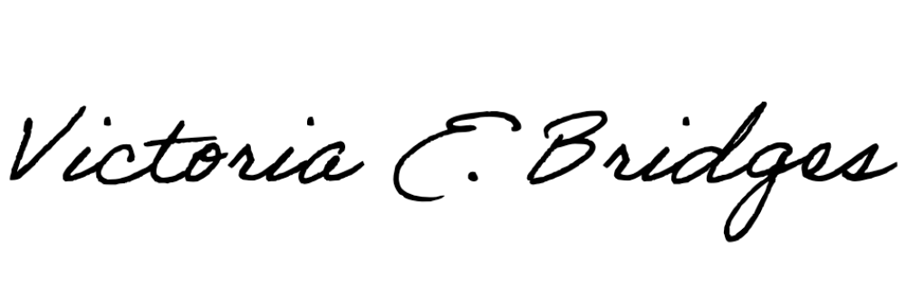
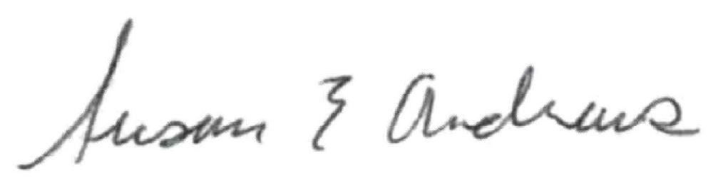
Region Board of Directors Approval
23 Oct 2025
Date
Signature of Region Director
25 October 2025

EGA Approval

EGA Approval

Date Signature of Chair, Chapter/Region Bylaws Review Committee

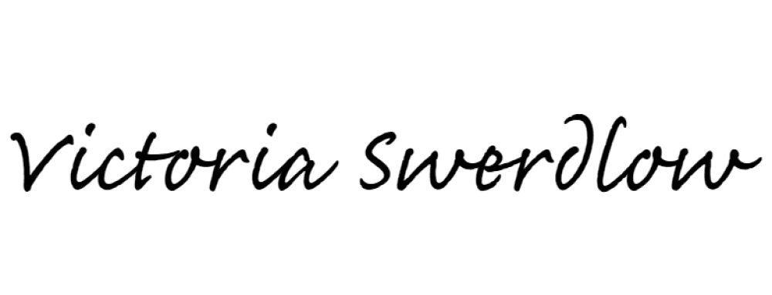
10/28/25
Date Signature of EGA Director of Bylaws

