SECTION VII

LOGOS AND MISCELLANEOUS INFORMATION
(Complete review done: 04/2026)

HYBRID/VIRTUAL (ZOOM) MEETINGS

For information regarding hybrid/virtual meetings, right click on the hyperlink below for the latest guidelines from EGA:

EGA-Zoom-Hybrid-Meetings.pdf (egausa.org)

LOGOS





Rocky Mountain Region Logo
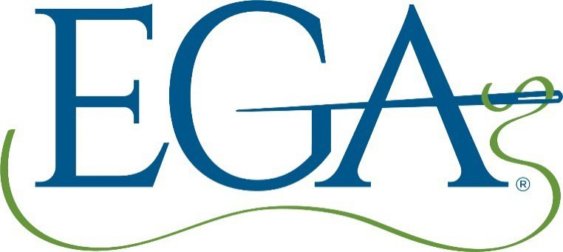
Current EGA National Logo


Legacy Logo (No longer in circulation)
For the most up to date information re: EGA branding, right click on the hyperlink Marketing: Logos, Brand Standards, and More | Embroiderers’ Guild of America (egausa.org), or contact Rand Duren at mail to:rduren@egausa.org.

EGA Diversity Statement
EGA is committed to providing a safe, inclusive, and supportive environment for stitchers of any experience level, age, race, ethnicity, nationality, ability, gender identity, sexual orientation, religion, or other background to develop their skills and express their creativity through the needle arts. EGA affirms the commitment to inclusion, diversity, equity, and accessibility (IDEA).

Student Code of Conduct
EGA fosters values of honor, mutual respect, cultural sensitivity, integrity, and responsible conduct. Students are expected to behave consistent with these principles, whether attending in- person or virtual classes, displaying principles of common courtesy towards their teacher and fellow classmates.
- Students will use their best efforts to listen during instruction and will not be disruptive.
- Students will not unduly monopolize the teacher’s time and attention to the detriment of their fellow classmates.
- Students will limit their contact with the teacher to classroom or online methods deemed acceptable by the teacher.
- At the discretion of EGA, students who violate the code of conduct may be asked to leave the class and/or event.

EGA Mission Statement
“Our Mission is to inspire passion for the needle arts through education and the celebration of its heritage.”

Needle Arts SUBMISSION GUIDELINES/FORM
Right click on the hyperlink below to get the most current guidelines for submitting articles to NeedleArts magazine:
Anc_4.1.1.7-Guidelines-for-Submitting-Articles-to-Needle-Arts-22-Jan-18.pdf (egausa.org) You can also contact EGA National Office with any document retrieval questions - Rand Duren: rduren@egausa.org

COPYRIGHT GUIDELINES
For information regarding copyright laws, right click on the hyperlink below for the guidelines from the EGA:
Anc_2.1.6.2.5-Copyright-Issues.pdf (egausa.org)

